Title (Times New Roman, 14pt, Bold, Centred)

First A. Author¹, Second B. Author², Third C. Author^{1, 2, 3} (Times New Roman, 10pt, Bold, Underline the presenting author’s name)
¹ Author’s affiliation: Dept. name of affiliation, Name of affiliation, City, Country (Times New Roman, 8pt, Italic, Centred)
² Author’s affiliation: Dept. name of affiliation, Name of affiliation, City, Country (Times New Roman, 8pt, Italic, Centred)
³ Author’s affiliation: Dept. name of affiliation, Name of affiliation, City, Country (Times New Roman, 8pt, Italic, Centred)

This document is a template of the abstract for the 13th THz Young Scientists Meeting 2023 and defines how the components of your text should be formatted. The abstract should be converted to a pdf file and submitted via the conference webpage.
The abstract length (main text) should be at most 1000 words. Use A4 (21 cm x 29,7 cm) page size with 2,55 cm margins on all sides. The title should be in Times New Roman, 14-point font, Bold and centred. Author names should be in Times New Roman, 10-point font, Bold, and aligned to the left. The presenting author's name should be underlined. The author's affiliations should be in Times New Roman, 8-point font, Italic, and centred. The main text should be in Times New Roman, 10-point font, and justified left and right. The references [1, 2] should be in Times New Roman, 8-point font, and aligned to the left. You can include a maximum of two figures (optional) to support your text. In that case, the Figure should be centred, and the Figure captions should be in Times New Roman, 8-point font, and centred. Please include at least three keywords summarizing your contribution's content. The keywords should be at the end of the document, in Times New Roman, 8-point font, Italic, and aligned to the left.

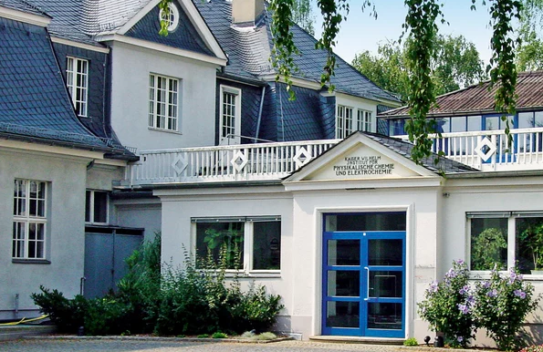
Fig. 1. (a) Department of Physics, Free University of Berlin; (b) Fritz Haber Institute (Times New Roman, 8pt).

References
[1] A. Author, B. Author, C. Author, Opt. Lett. 13, 4634 (2022).
[2] C. Author, et al., Appl. Opt. 120, 10714 (2022).

Keywords – THz propagation, THz Scanning Tunneling Microscopy, THz-Raman spectroscopy…

