Gas-Phase IR Spectroscopy of Ion-Mobility Separated Biomolecules
Jan Horlebeinª, Jerome Riedel^{b}, Maike Lettowª, Eike Muchaª,
Gerard Meijerª, Kevin Pagel^{b}, Gert von Heldenª

Conventional condensed phase approaches for the analysis of biomolecules, such as nuclear magnetic resonance (NMR) and X-Ray spectroscopy, often require large amounts of high purity samples and are therefore not universally applicable. Mass spectrometry (MS) on the other hand requires only minute amounts of sample and its purity is often not an issue. However, the amount of structural information obtained directly by MS is limited. Nonetheless, by combining the benefits of MS with ion-mobility mass spectrometry (IM-MS) and gas phase infrared spectroscopy, a rather large amount of information can be obtained: IMS separates molecules by their collision cross section (CCS)/charge ratio and can be used as a separation technique as well as a method to obtain information of the global structure. Subsequent cryogenic IR spectroscopy yields then detailed information on the various covalent and non-covalent interactions in the molecule.
Here we report a novel implementation to combine MS with IMS and cryogenic IR spectroscopy. Leveraging on the benefits of nano electrospray ionization (nano-ESI), biomolecules are transferred to the gas-phase under soft conditions and enter the ion-mobility section. Ions are then separated based on their size, mass and charge in a linear drift tube by collisions with an inert buffer gas. Based on the arrival time of the molecules travelling through the drift tube, different conformations of molecules can be isolated and selected for the transfer to the cryogenic ion trap. In the trap, ions are cooled to ~40K and tagged with weakly binding neutral molecules (for example N₂). When such tagged ions absorb one (or more) photons from the FHI free electron laser, the tag can dissociate from the ion and monitoring the amount of tagged and untagged species as a function of IR wavelength can yield an IR spectrum. First results will be presented.
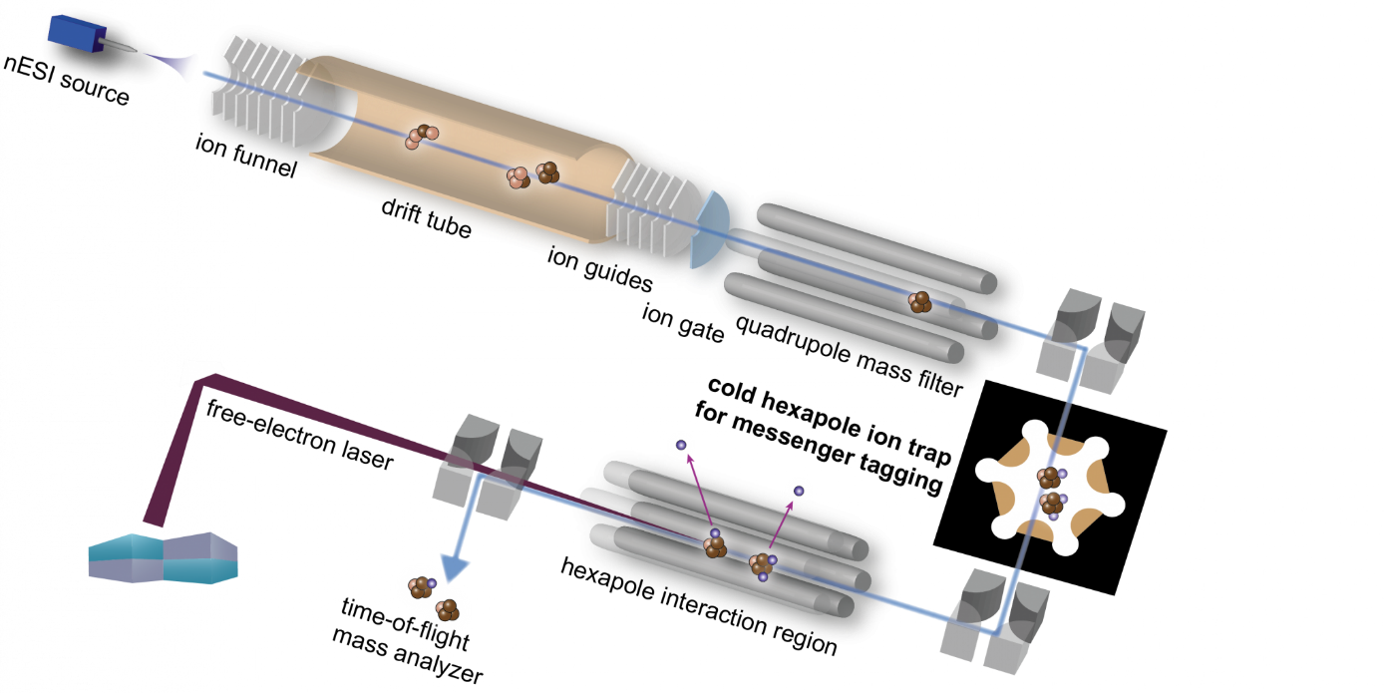
Figure: A schematic of the new iMob2.0 instrument

